**1. INTRODUCTION**

**1.1** **over view**

**Firstly, we have collected the data and then we have extracted from data base, then we prepared the data, next we have done the data visualization, then we use dash board to show the differences and similarities, then we created a data story, then we done the performance test, then we have done the web integration and then lastly, we have done the project demonstration and documentation.**

1.2 **purpose**

**The purpose of this project is to demonstrate and analyze the co2 emission all over the world, this help researchers and environment experts to predict global warming.**

**2 PROBLEM IDEATION AND DESIGN THINKING**

**2.1 Empathy map**

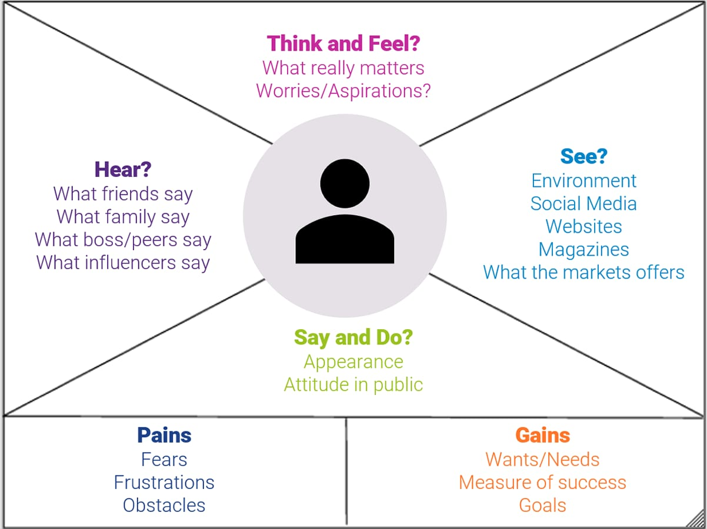

**2.2 Ideation and Brainstorming map**

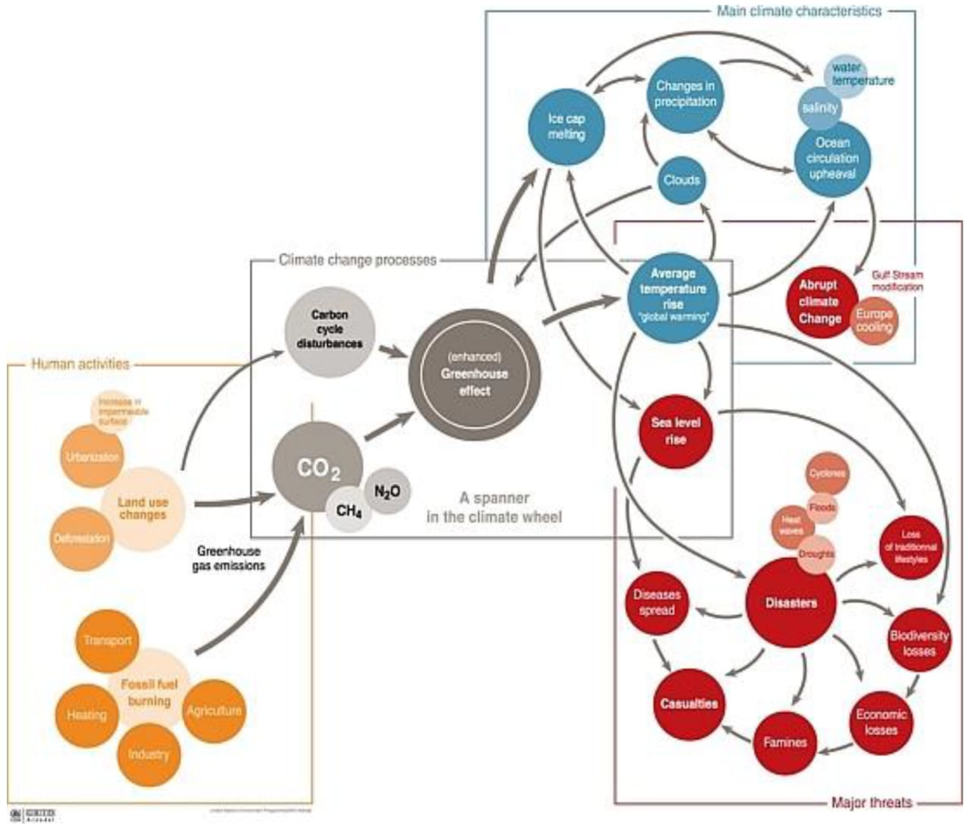

**3 RESULTS**

**Dash board**

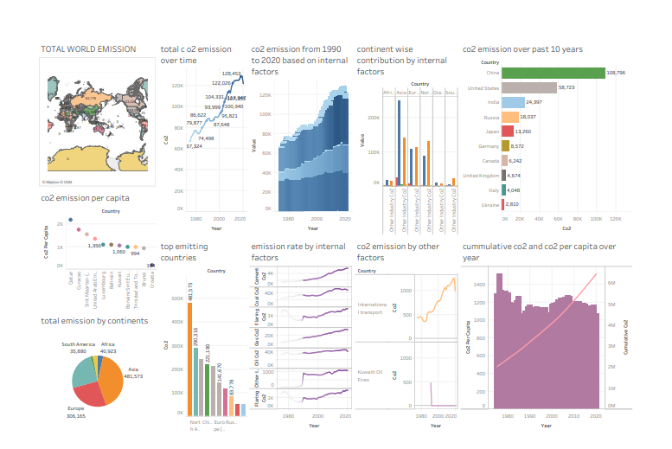

**story**

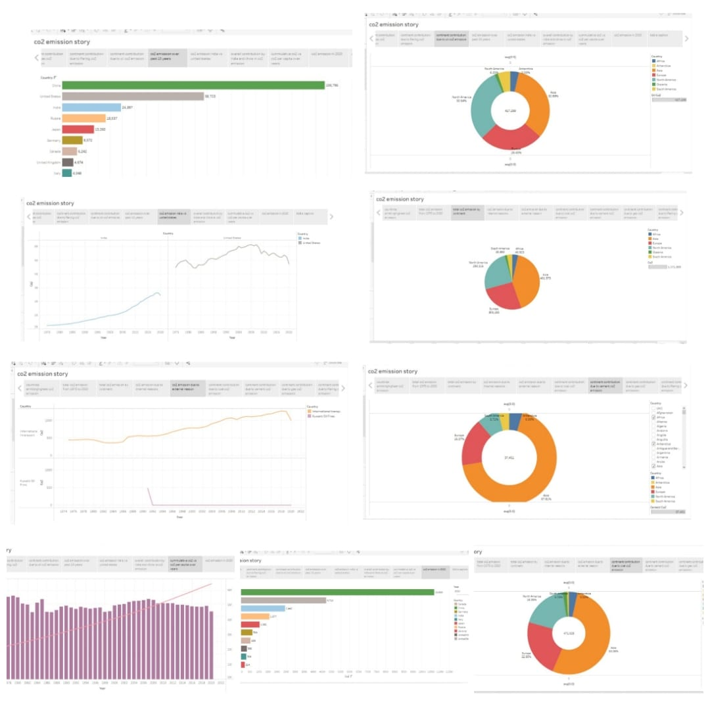

**web application**

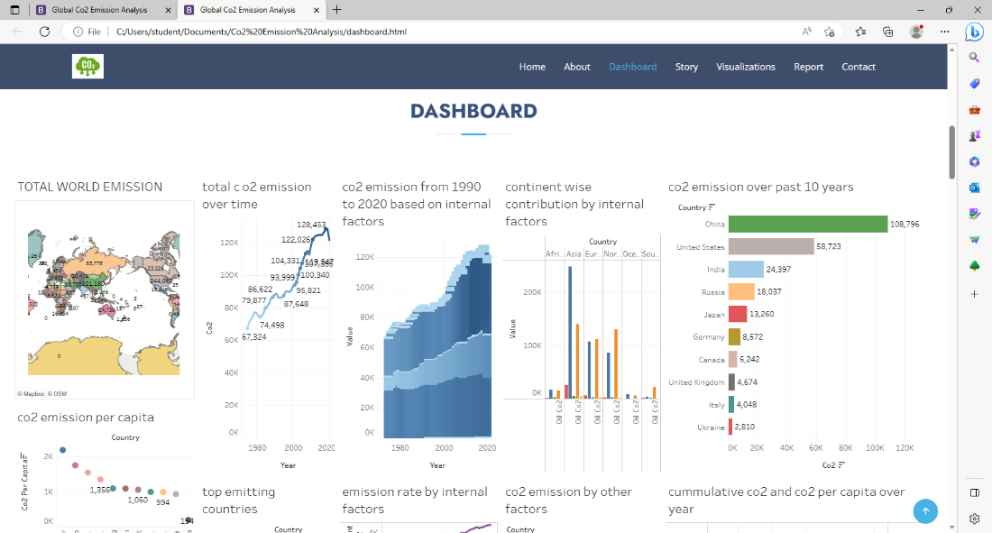

1. **ADVANTAGE AND DISADVANTAGE**

**Advantage:**

**The captured co2 is incorporated into concrete reinforce it and increase the durability of the** **infrastructure .** **the carbon capture operation** **create employment for skilled engineers and technicians who need to operate them.**

**Disadvantage:**

**The technologies for carbon capture have some cost implications attached to them. Therefore, it can be very costly for power plants to generate electricity through fossil fuels.it can lead to environmental contamination if not handled correctly.**

1. **APPLICATION**

**This can be applied in transportation, logistic and delivery, web search or internet web result,** **manufacturing, security, education,** **healthcare, military,** **insurance, digital advertisement, fraud and risk detection, travel, communication, media and entertainment, energy and utility etc.**

**6 CONCLUSIONS**

**By doing this project we have learnt collaboration, problem solving, creativity, in depth understanding, self-confidence, critical thinking, perseverance, project management, curiosity** **and empowerment.**

**7 FUTURE SCOPE**

**By using tableau at secondary level, we can be visioned for modern** **analytics and we can** **broad use this data for aspirational and actionable as well as we can achieve our specific goals.**